Jaipur Engineering College and Research Center, Jaipur



REPORT ON

INDUCTION PROGRAMME

B. Tech. First Year

1stAugust to 14thAugust, 2019

**Purpose & Objective of Induction Program**

* To help new students adjust and feel comfortable in the new environment
* To inculcate in them the ethos and culture of the institution
* Help them to build bonds with other students and faculty members
* Expose them to a sense of larger purpose and self exploration

**Start Up Talks**

**Industry Talks**

**Motivational Talk**

**Entrepreneurship Talk**

**Introduction to Branch by HODs**

**Major Components of Induction Program**

**Interactive Hours**

**Activity Hours**

**Teaching Hours**

**Start Up Talks**

**City Visit**

**Physical Activity**

**Proficiency Module**

**Literary Activity**

**Environment & Social Awareness**

**Theory Classes**

**Laboratory Classes**

**Laboratory Classes**

Glimpses of Induction Program

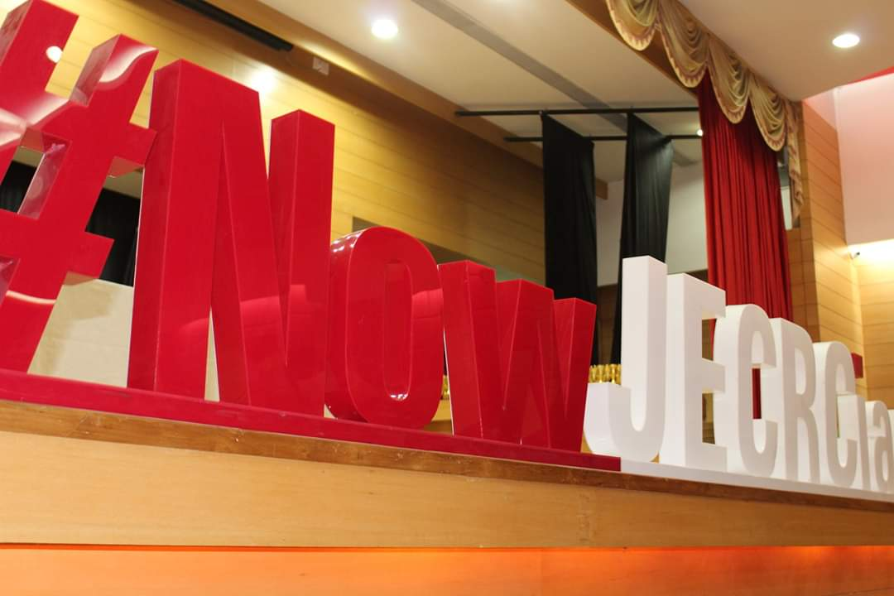

|  |  |  |
| --- | --- | --- |
| C:\Users\User\Downloads\IMG_4004.JPG | C:\Users\User\Downloads\IMG_4013.JPG | C:\Users\User\Downloads\IMG_4029.JPG |
| C:\Users\User\Downloads\IMG_2348.JPG | C:\Users\User\Downloads\IMG_2342.JPG | C:\Users\User\Downloads\IMG_4072.JPG |
| C:\Users\User\Downloads\IMG_2463.JPG | C:\Users\User\Downloads\IMG_2486.JPG | C:\Users\User\Downloads\IMG_2539.JPG |

**Interactive Session:- Students got the chance to interact with eminent speakers to learn and experience their knowledge**

* **Start Up Talks : Bringing together the Brightest talent to build well connected community**

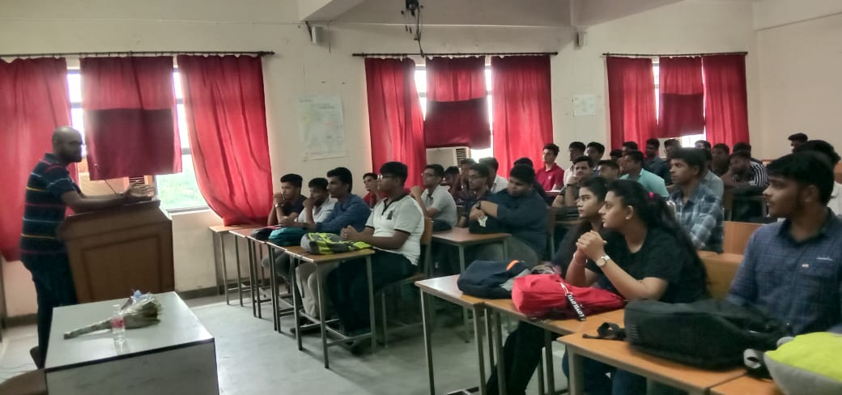 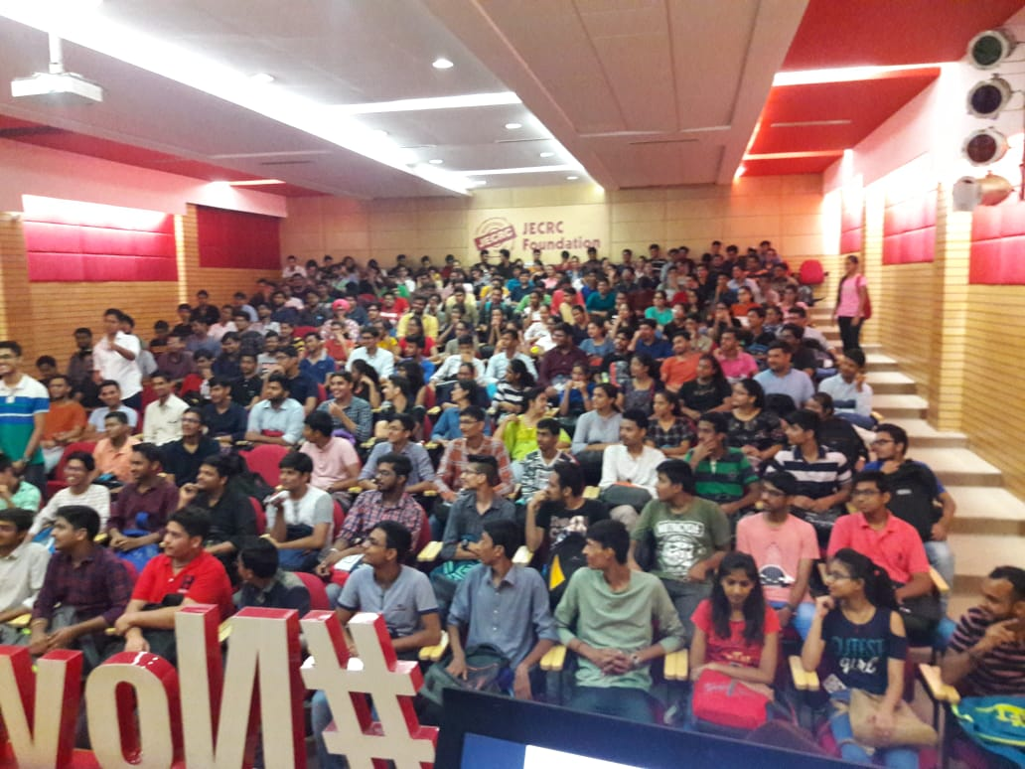

* **Industry Talks : Hear from leading industry experts on the current state and future direction**

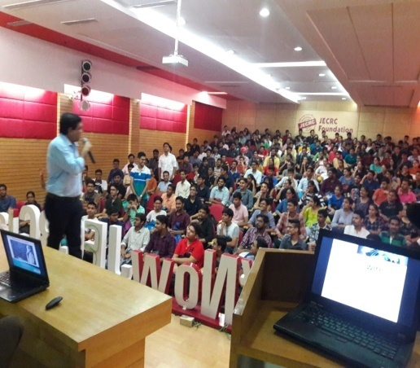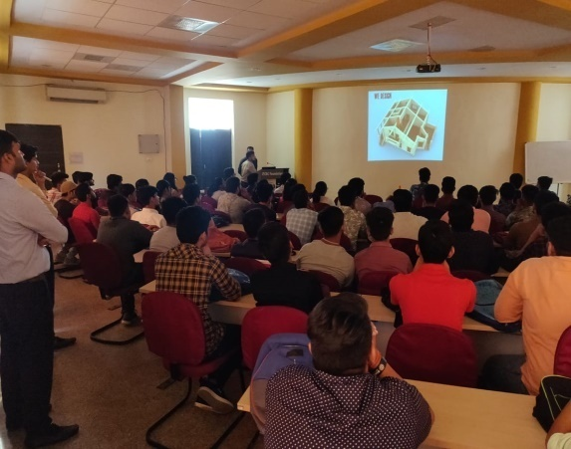

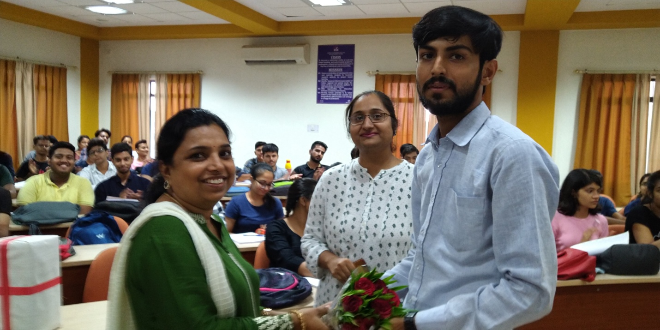

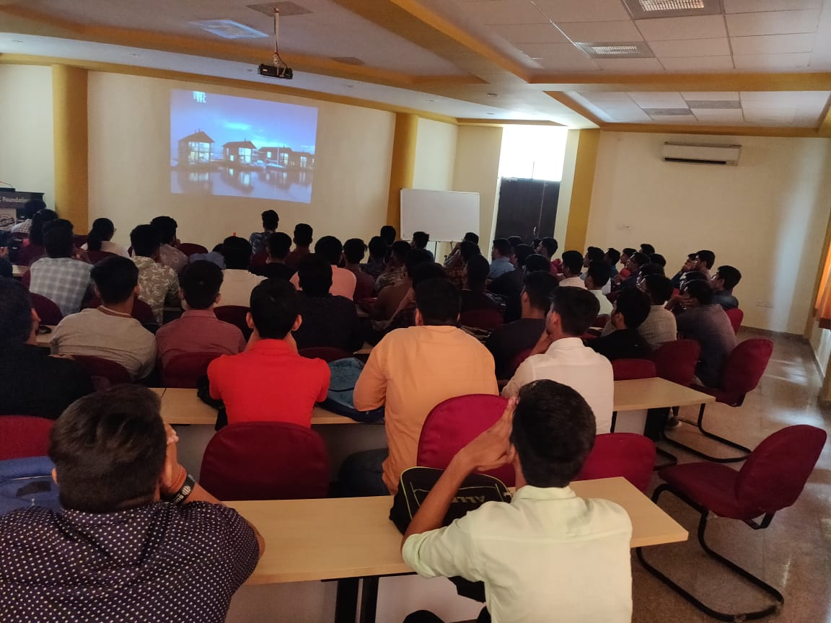

* **Motivational Talks: To achieve your goals and dreams in life you need a wake up call by these talks.**

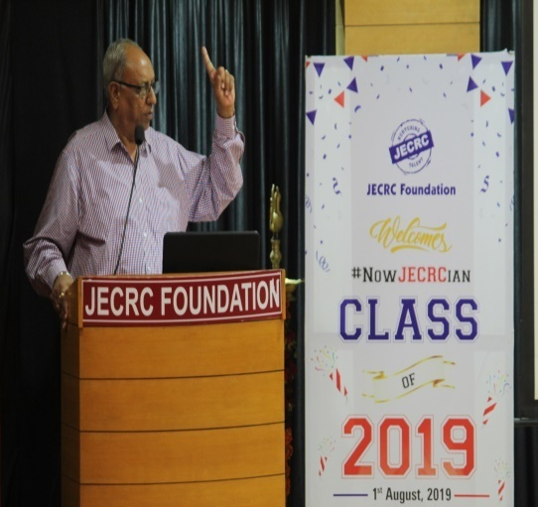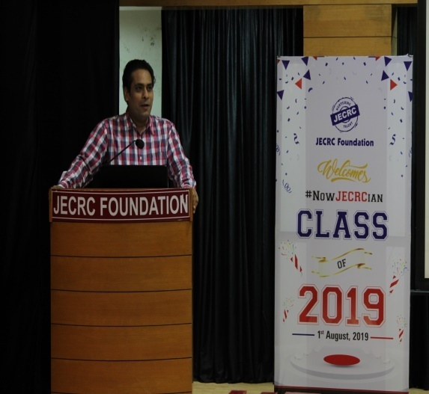

* **Entrepreneurship Talks: Learning the process of designing , launching and running a new business**

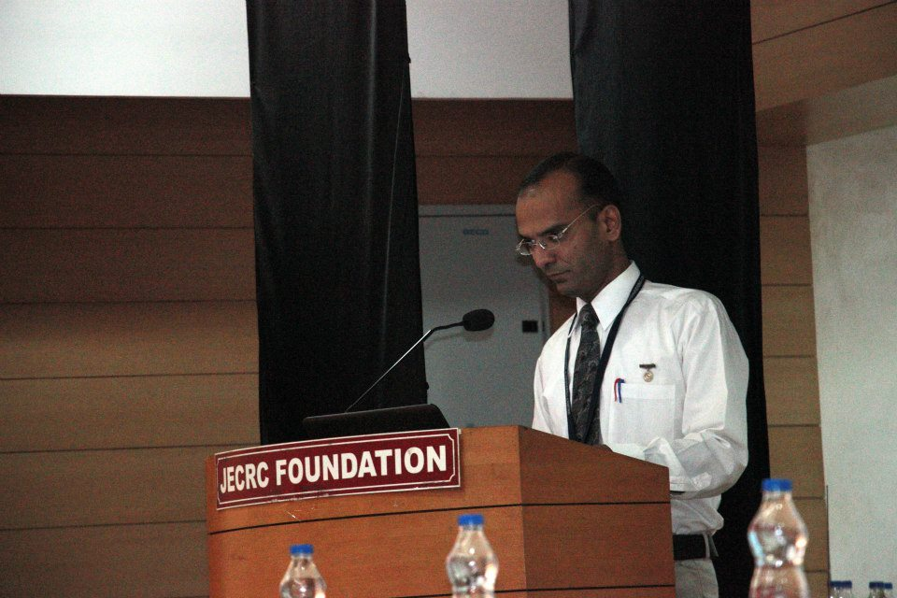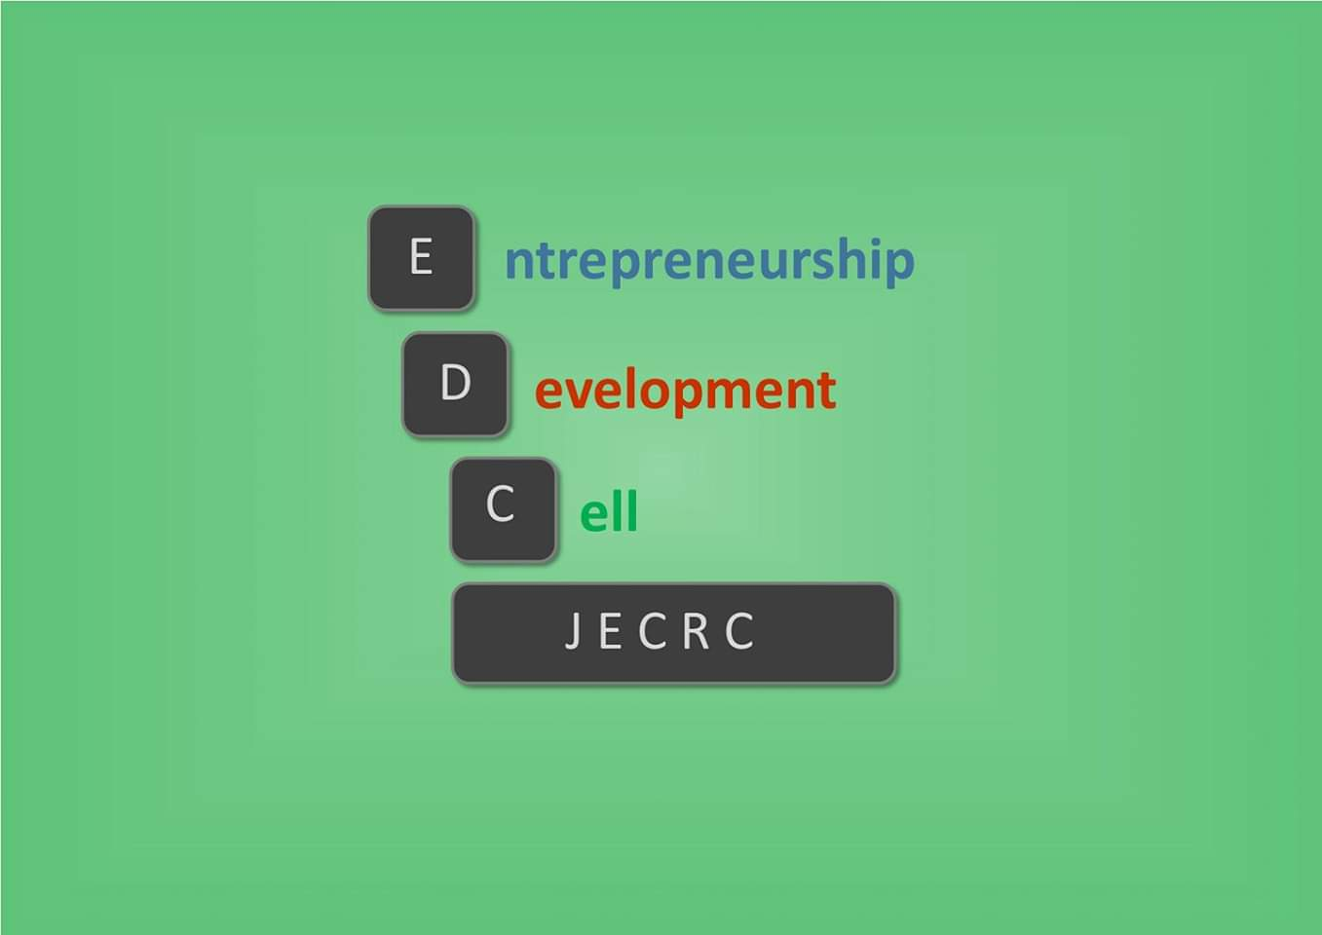

* **Branch Specific sessions by HODs: Time to know about your department**

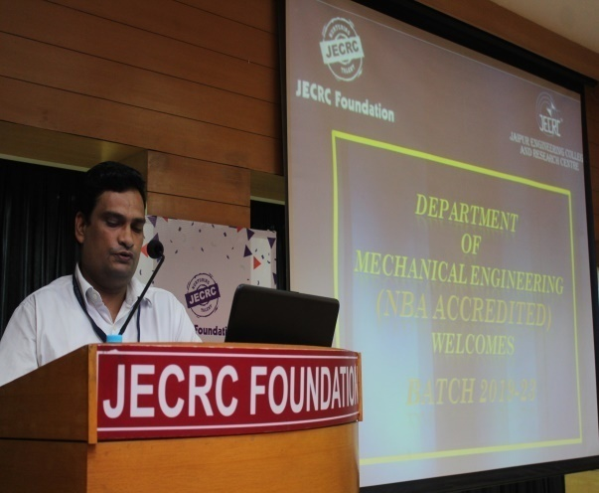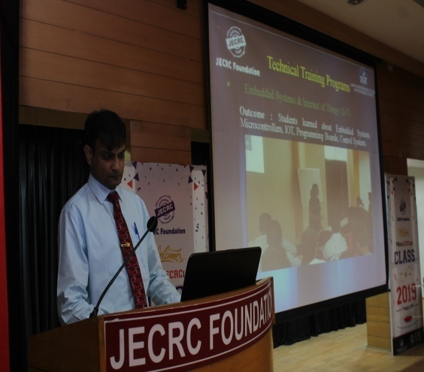

**Activity Hours: A lot of action and movement is planned during induction for holistic development of students**

* **City Visit : To familiarize students about the surroundings and strengthen the bond among themselves**

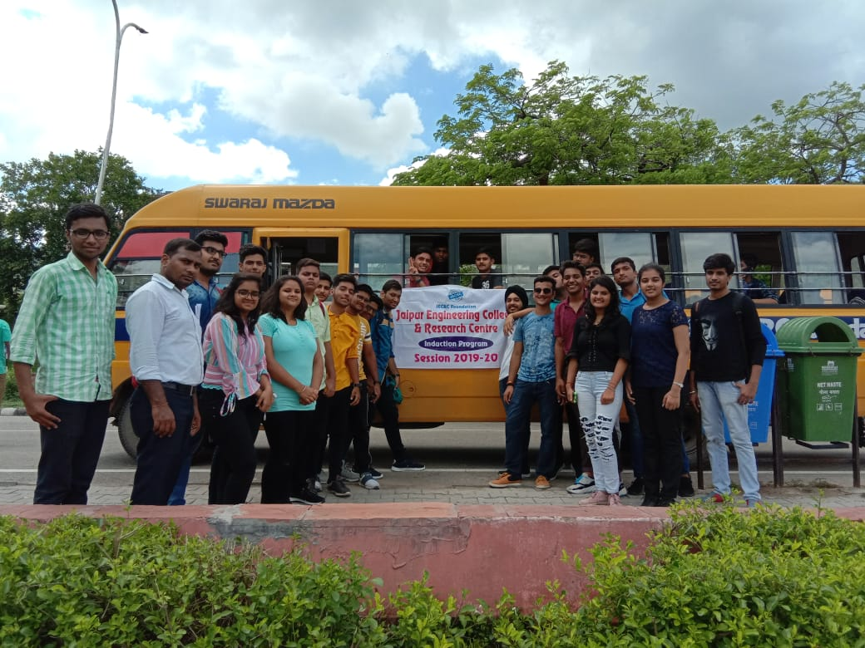

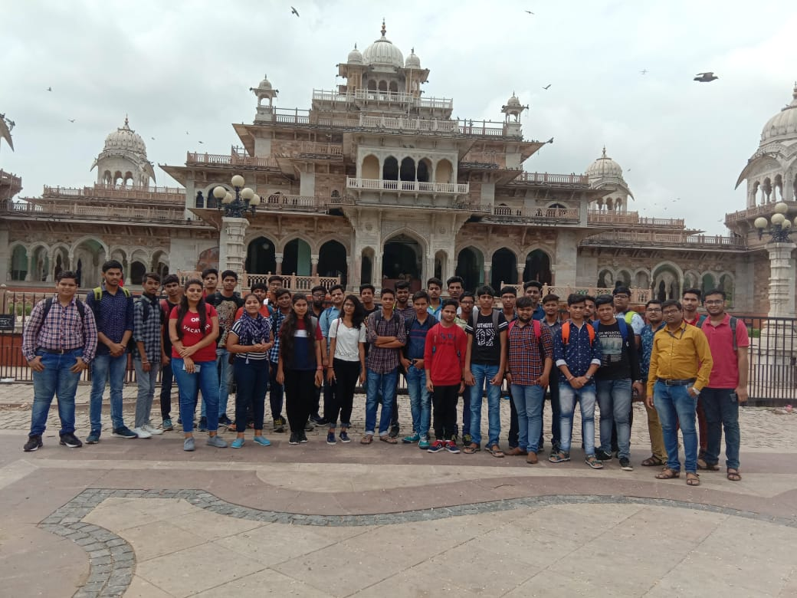

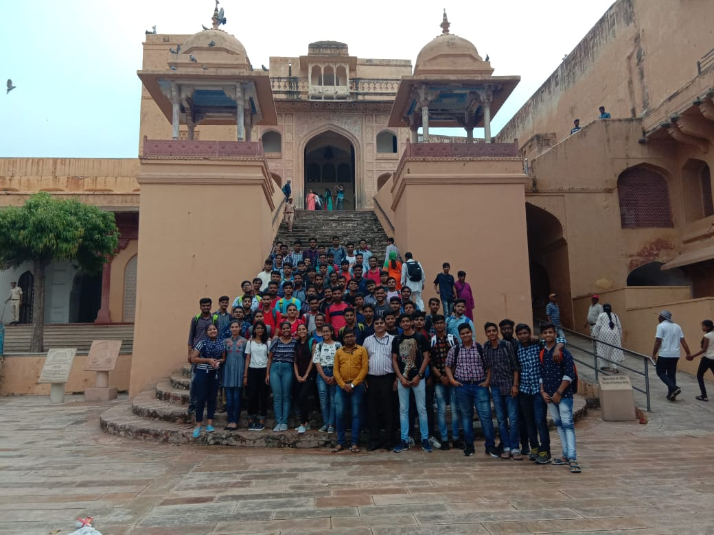

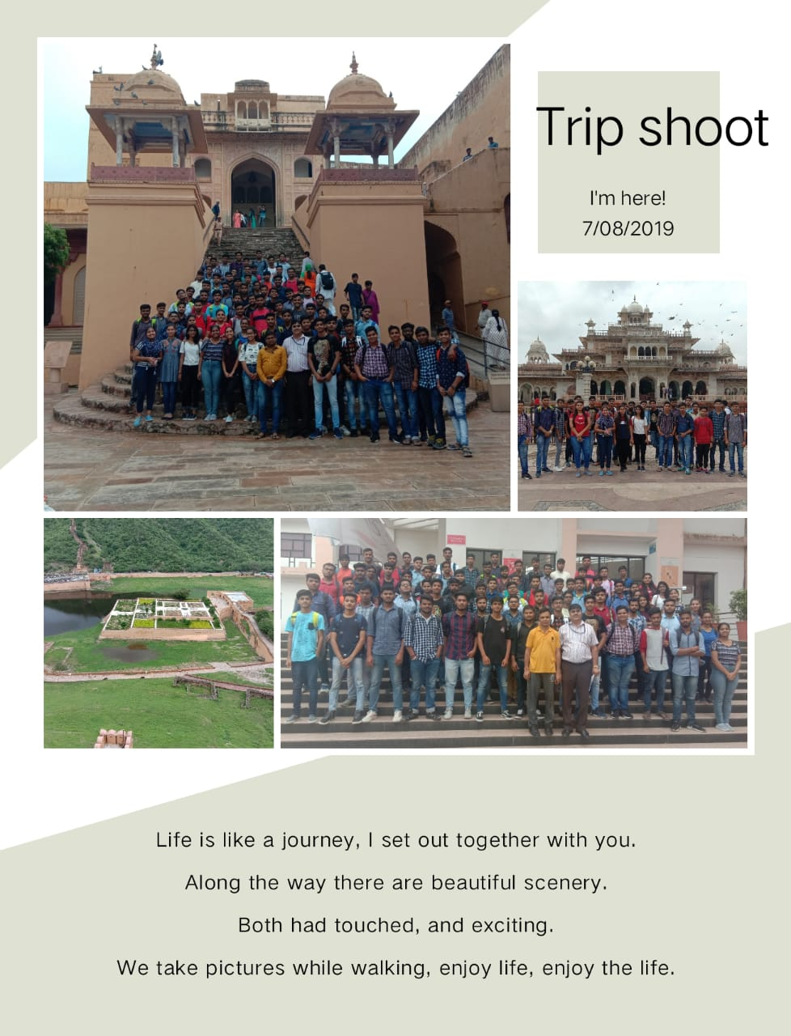

* **Physical Activity : To help students learn about team work besides work and importance of healthy mind in healthy body.**

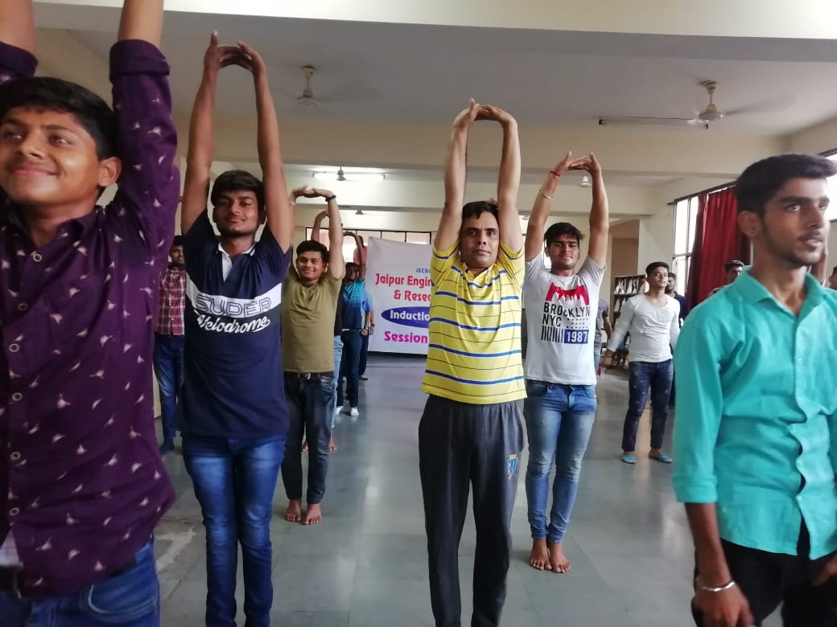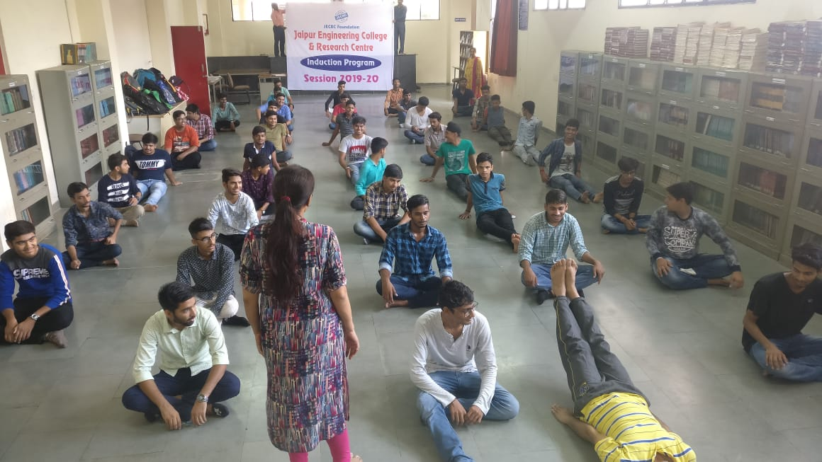

**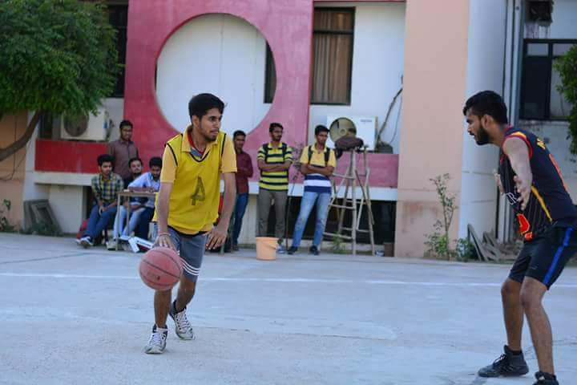**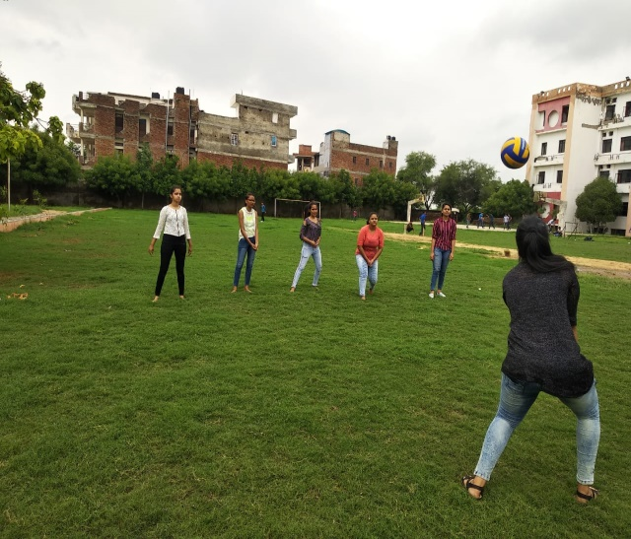

**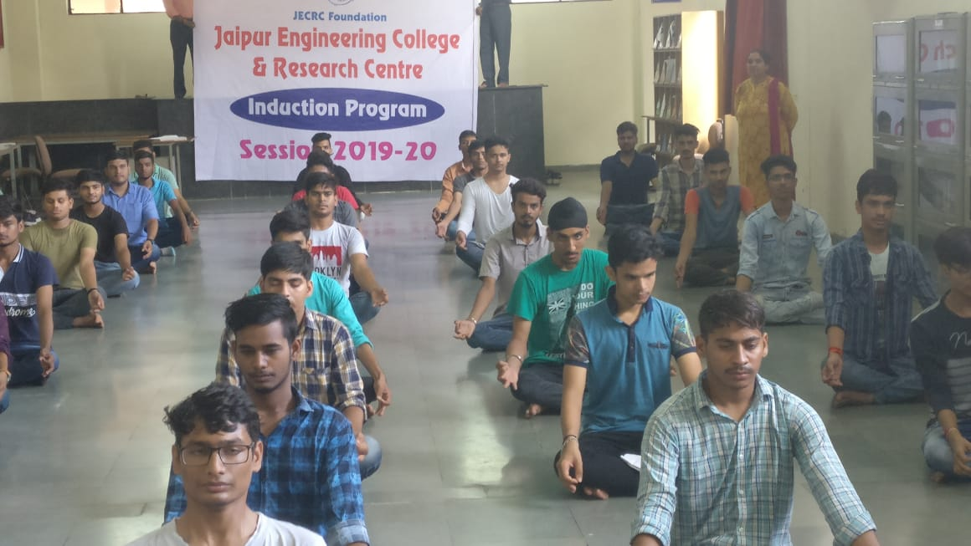**

* **Proficiency Module: Allows students to overcome their shortcomings and learn new skills like communication and computers to build up their confidence.**

**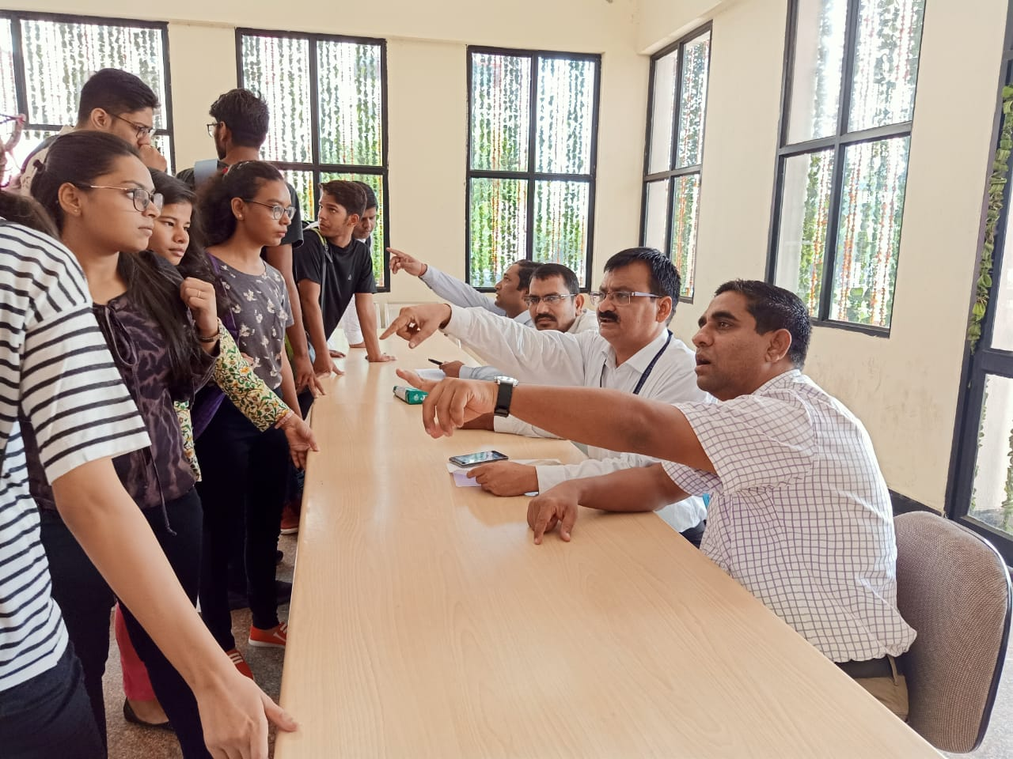**

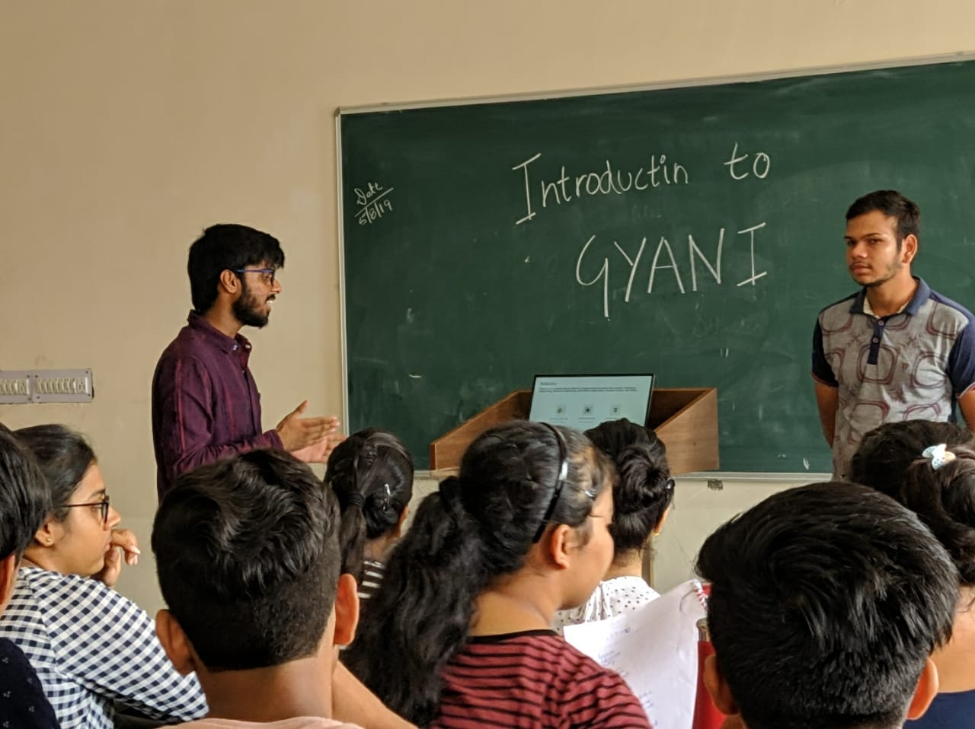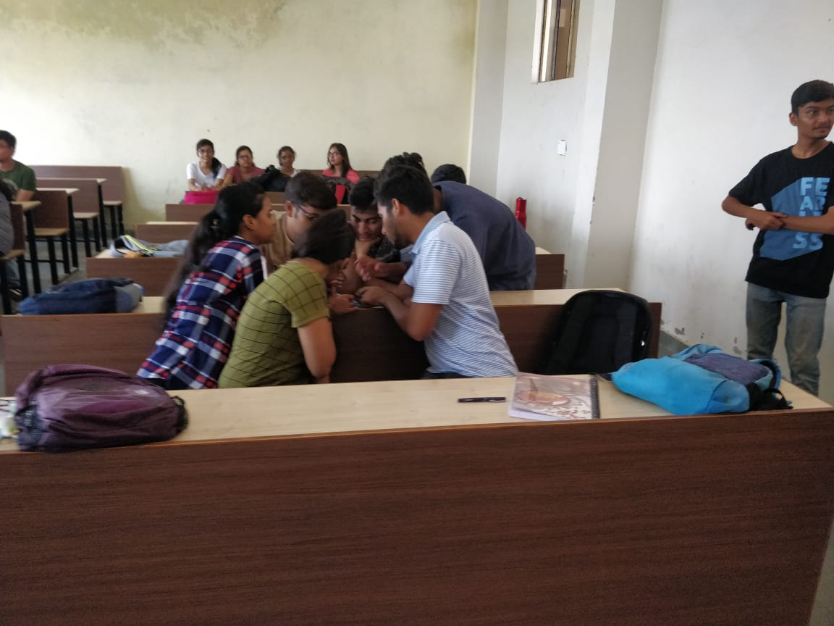

* **Literary Activity: To develop understanding and importance of reading, research and Moocs.**

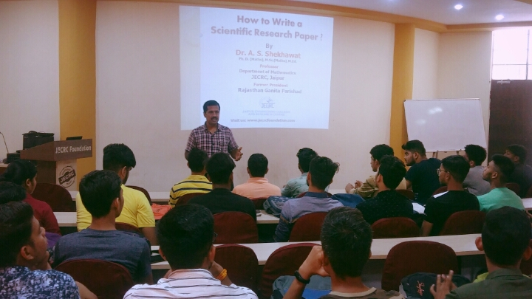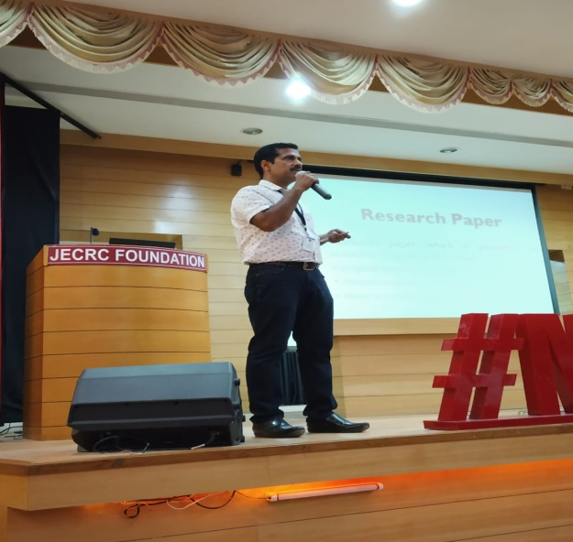

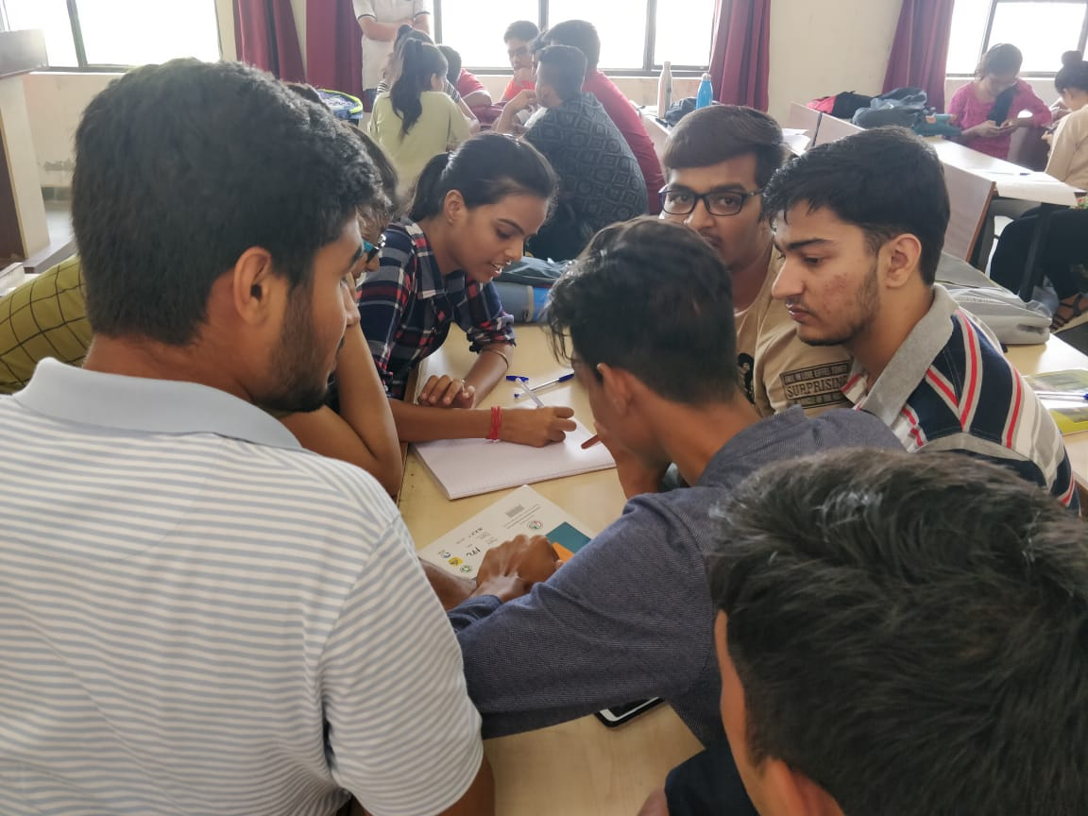

* **Environment and Social Awareness: To develop sense of responsibility towards environment by planting trees and discussing social issues**

**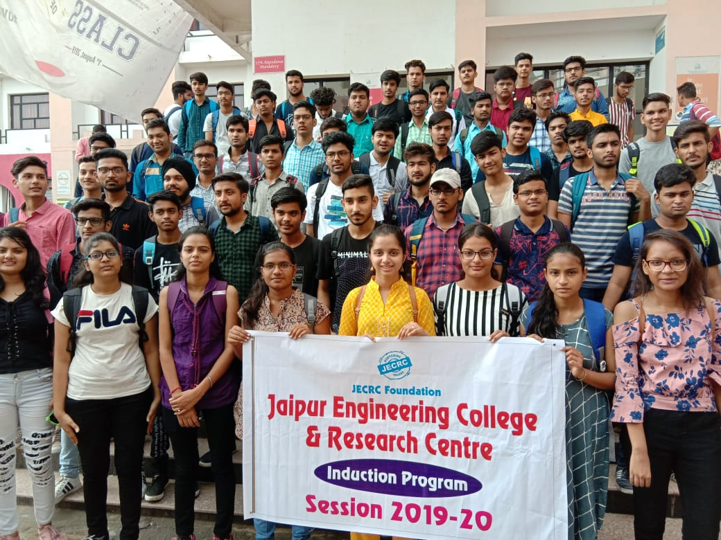**

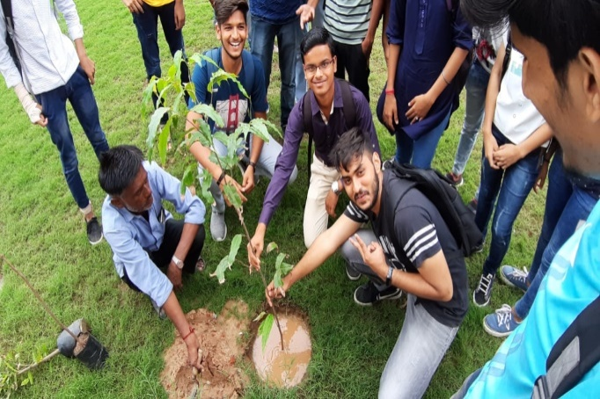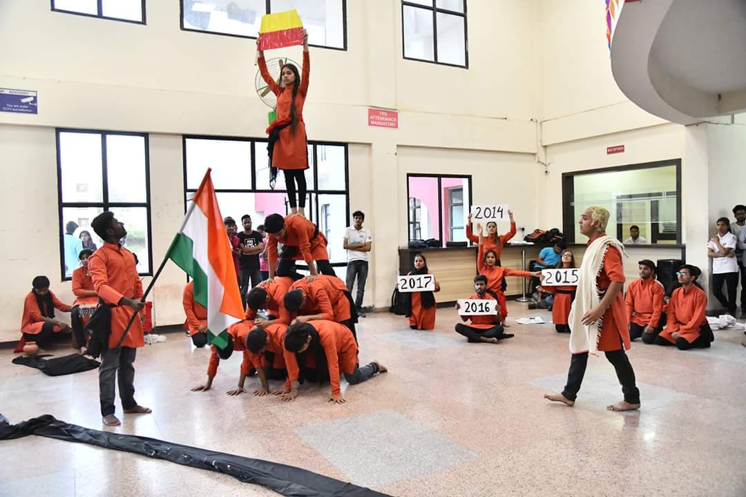

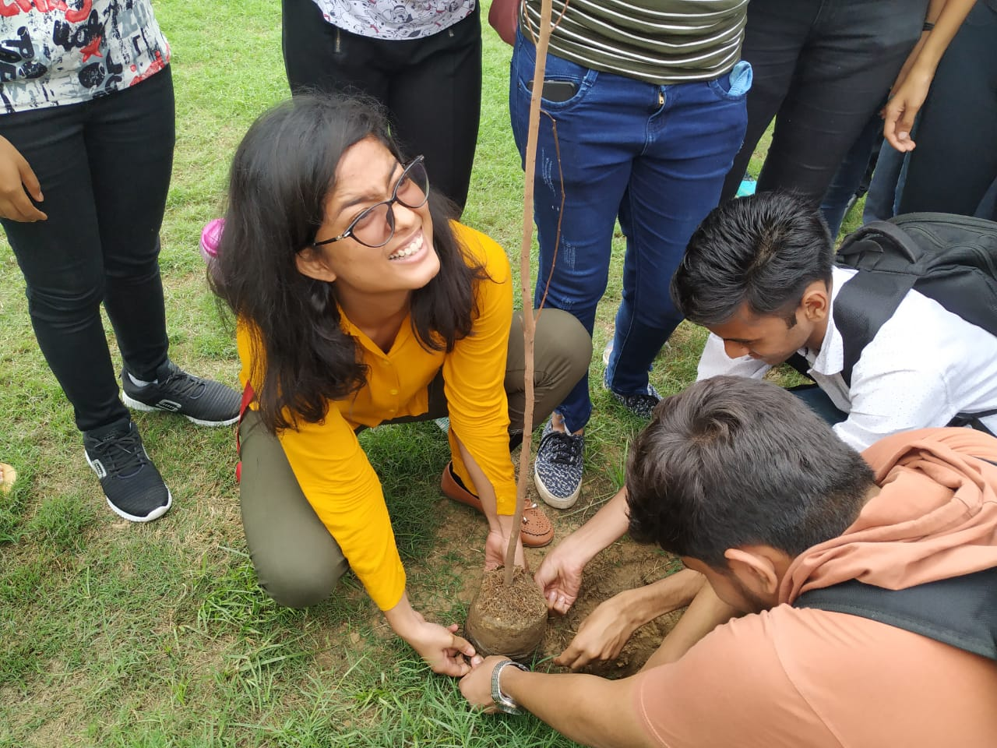

**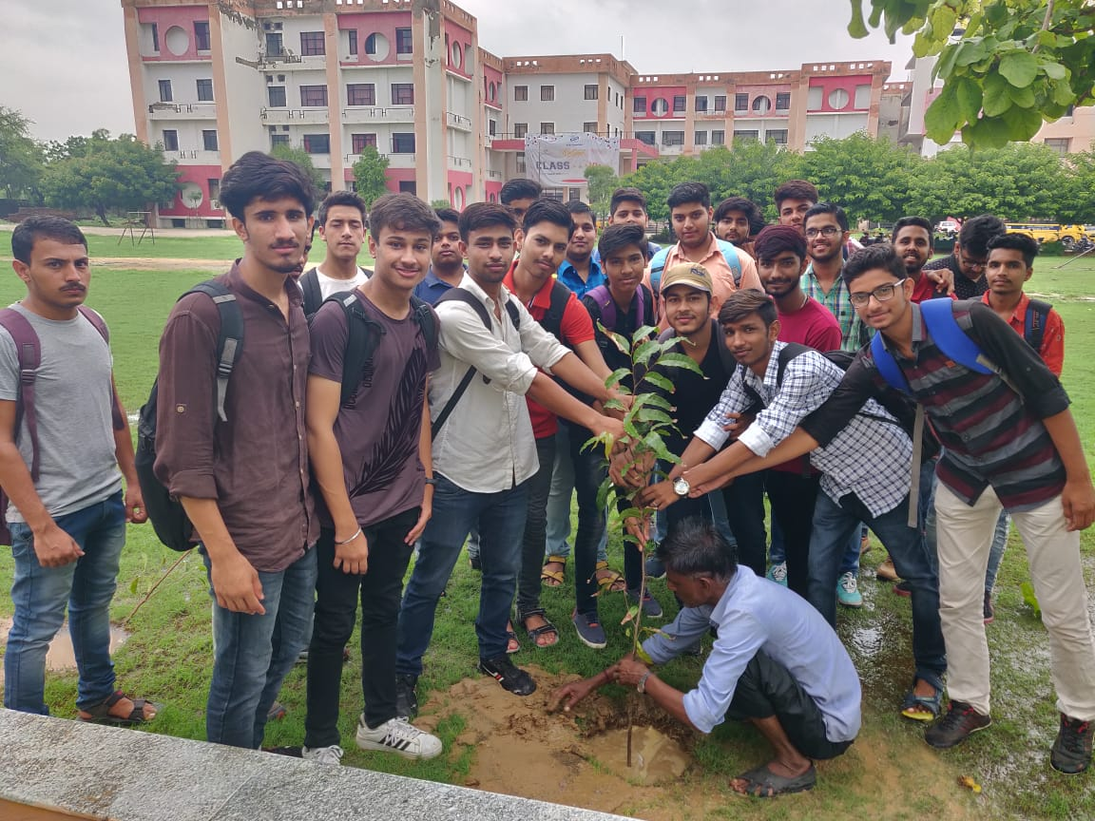**

**Teaching Hours:- A step toward studious life of a budding engineer**

* **Theory classes : Knowledge of subjects to groom young minds**

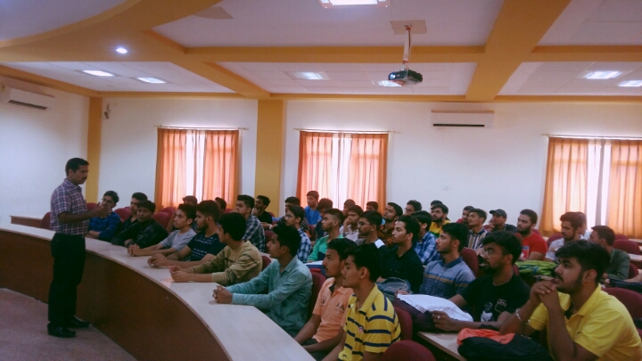

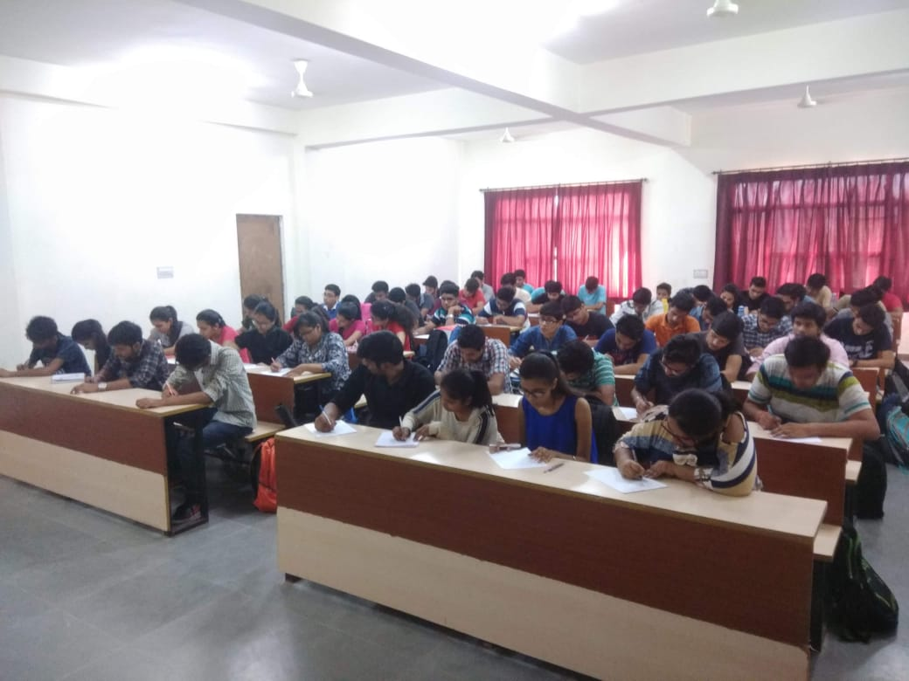

* **Laboratory classes : Developing practical knowledge for future innovations**

